1/6/2026
Submitted To: Sir Ghulam Ali
Submitted By: Wasif Ali
Reg ID: 245187
Class: BSCS F’24 3B
ASSIGNMENT NO 04
VISUAL PROGRAMMING

Blazor-Based Low-Code / Visual Programming System Documentation

1. Introduction
This document presents a comprehensive and professional report for a Blazor-based application developed from a Low-Code / Visual Programming (VP) perspective. The purpose of this documentation is to demonstrate how modern web applications can be created with minimal manual coding effort by leveraging reusable components, declarative UI design, and event-driven programming.
The system is designed around common entities such as Task and Appointment and showcases how Blazor simplifies UI development, state management, form handling, and data interaction. This report is suitable for academic evaluation and fulfills the requirements of a 3–5-page technical documentation.
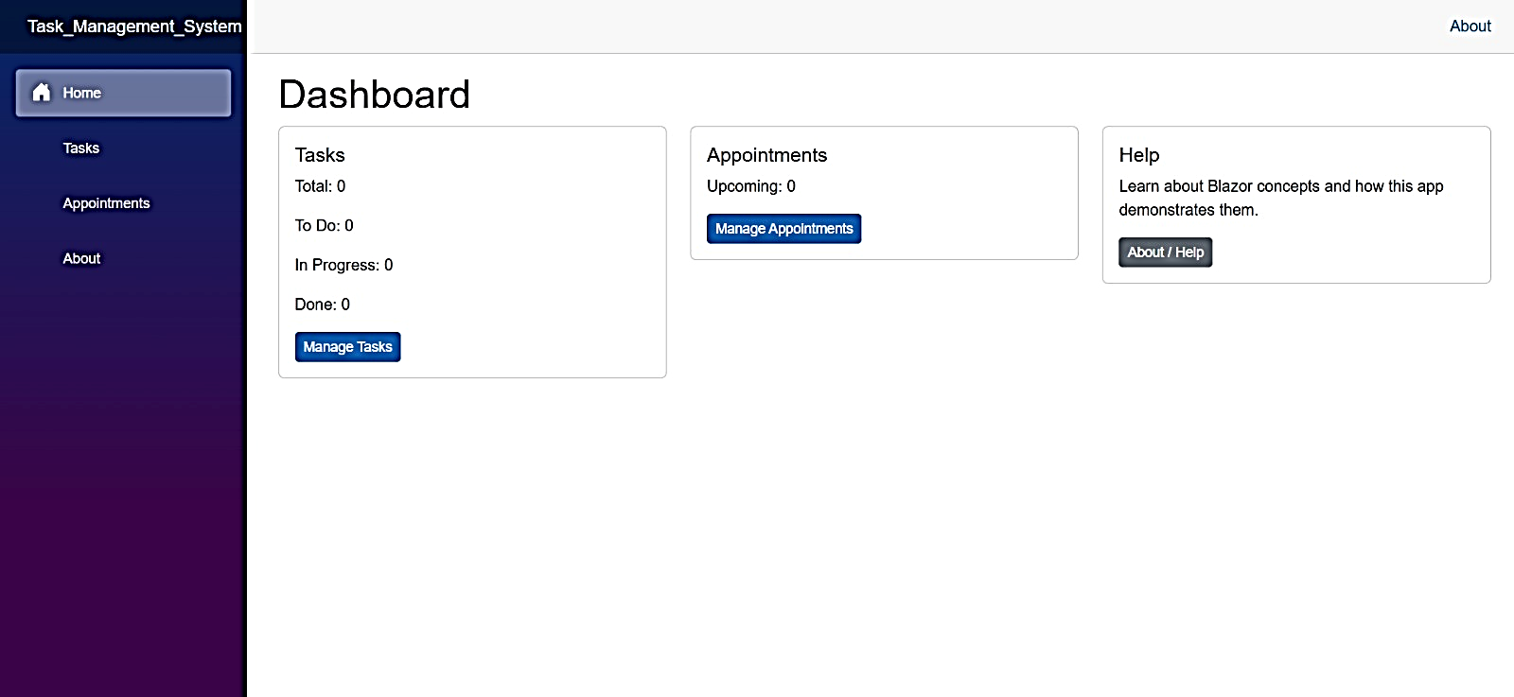

2. Low-Code / Visual Programming Perspective
Low-code and visual programming aim to reduce the amount of handwritten code by enabling developers to assemble applications using visual components and predefined logic blocks. Blazor strongly aligns with this paradigm by allowing developers to focus on application logic rather than low-level UI implementation details.
From a visual programming perspective, Blazor applications are constructed by combining components that represent functional UI blocks. These components encapsulate both presentation and behavior, enabling rapid development, easier debugging, and improved maintainability.
Key low-code characteristics of Blazor include: - Component-based UI construction - Declarative Razor syntax - Built-in data binding and validation - Event-driven programming using C# - Minimal reliance on JavaScript
This approach significantly lowers development complexity while increasing productivity.

3. Reduction of UI Boilerplate Code in Blazor
Blazor significantly reduces UI boilerplate code by: - Combining HTML and C# logic in. razor components - Eliminating repetitive JavaScript for DOM manipulation - Providing built-in directives such as @bind, @onclick, and @if - Supporting reusable layouts and components
Example Concept: Instead of manually selecting elements and attaching event listeners (as in JavaScript), Blazor binds UI elements directly to C# properties and methods.

4. Components as Visual Programming Units
In Blazor, components act as visual programming blocks. Each component: - Represents a self-contained UI unit - Has its own markup, logic, and state - Can be reused and composed with other components
Examples of components in the system: - TaskListComponent - TaskFormComponent – AppointmentComponent.
This approach aligns with visual programming where applications are built by assembling functional blocks rather than writing linear code.

5. Event Handling in Blazor vs Traditional JavaScript

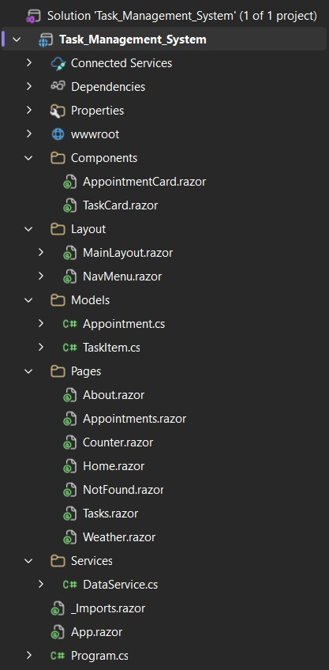
Traditional JavaScript:
- Requires manual DOM selection
- Uses event listeners (e.g., addEventListener)
- Separates UI from logic

Blazor Event Handling:
- Events are handled directly in Razor markup
- Uses C# methods instead of JavaScript functions
- Supports strongly typed event handling
Example Concept: A button click directly calls a C# method using @onclick, improving readability and maintainability.

6. Form Validation using EditForm
Blazor provides the EditForm component for structured and validated form handling.
Key features: -
- Model-based validation
- Integration with Data Annotations
- Automatic validation feedback
Validation workflow:
- User submits the form
- Blazor validates the model
- Errors are displayed without page reload
This eliminates the need for custom JavaScript validation logic.

7. Component Lifecycle Methods (OnInitialized)
Blazor components follow a defined lifecycle. The OnInitialized() method: - Executes when the component is first initialized - Used for loading initial data - Ideal for calling services or setting default state.
This ensures predictable initialization and clean separation of setup logic.

8. In-Memory Data Service
The system uses an in-memory data service to store and manage application data.
Characteristics: - Data is stored temporarily during runtime, No external database dependency, Ideal for prototypes and academic projects
Responsibilities: - CRUD operations for Task and Appointment entities, Acts as a shared data source across components.

9. Simple CSS Styling
Styling is handled using simple and modular CSS: - Component-scoped CSS files - Clean and minimal UI - Separation of concerns between logic and presentation
This approach ensures maintainability while keeping the UI visually consistent.

10. State Sharing Between Components
Blazor allows state sharing using: - Dependency Injection - Shared services (Singleton or Scoped)

State Flow:
- A shared service holds the application state
- Multiple components consume the same service
- UI updates automatically when state changes

State Diagram (Textual Representation):
[User Action]
↓
[UI Component]
↓
[Shared State Service]
↓
[Other Components Updated]
This ensures synchronization across the application.

11. Entity Relationship Diagram (ERD)

Entities:

Task
- TaskID (Primary Key)
- Title
- Description
- Status
- DueDate

Appointment
- AppointmentID (Primary Key)
- Subject
- Date
- Time
- TaskID (Foreign Key)

Relationships:
- One Task can have multiple Appointments
- Each Appointment is linked to one Task

ERD (Textual Representation):
Task (TaskID)
|
| 1-to-Many
|
Appointment (AppointmentID, TaskID)

12. ERD Explanation

Database Schema Design
- Task table stores core task information
- Appointment table references Task using a foreign key
- Ensures data integrity and logical grouping

Interaction Between Blazor Components and Database
- UI components trigger events (Add, Edit, Delete)
- Events call methods in the data service
- Data service updates in-memory collections
- UI re-renders automatically

13. Event-Driven Workflow of the System
The system follows an event-driven architecture, where user actions trigger application logic and data updates. Blazor simplifies this workflow by tightly integrating UI events with backend logic written in C#.

Workflow Steps:
- The user performs an action such as clicking a button or submitting a form.
- The UI component captures the event using Blazor event bindings.
- A corresponding C# method is executed.
- The in-memory data service processes the request (Add, Update, or Delete).
- Application state is updated within the shared service.
- All subscribed components automatically re-render.
This event-driven model ensures a responsive user experience and eliminates the need for manual DOM updates.

14. Tools and Technologies Used
The following tools and technologies were used in the development of this system: - Blazor (.NET) for UI development - Razor Components for visual programming units - C# for application logic and event handling - EditForm & Data Annotations for validation - In-Memory Data Service for data management - CSS for UI styling

15. Conclusion
This Blazor-based application successfully demonstrates the principles of low-code and visual programming in a modern web environment. By utilizing reusable components, built-in validation, shared state management, and event-driven workflows, the system minimizes boilerplate code while maintaining clarity and scalability.
The inclusion of ERD design, state-sharing mechanisms, and lifecycle management further strengthens the architectural quality of the application. Overall, this project serves as a strong academic example of how Blazor can be used to develop efficient, maintainable, and visually structured applications with minimal coding overhead.

